**Web Programming**

**Btech SEM:V (20-21)**

**Program 1**

**PART-A**

**A.1 Aim:**

Create a static web pages using HTML that has

1. Home Page

2. Registration page

3. Contact Us page (optional)

**A.2 Prerequisite:**

There are no prerequisites as such to learn and implement HTML.

**A.3 Outcome:**

After successful completion of this experiment students will be able to

1. Understand the basic Technique in building a static web application using HTML

2. Implement basic tags of HTML

3. Understand usage of basic editor like Sublime Text 2 or 3

**A.4 Theory:**

A website is a collection of web pages. A web page holds some useful content along with images, videos, audio, animations, links to other pages and so on. These web pages are created with HTML. When executed, web pages open in browser and browser interprets HTML code and displays information.

HTML stands for Hyper Text Markup Language. It is a major language of the World Wide Web. It is simply a collection of **tags < >** that indicate the structure and format of a web document. Tags have **attributes**.

Every Web page when designed with HTML starts with <html> tag.

* This is a basic structure of simple web page. It prints My name is Yourname in browser when executed

**<HTML>**

**<HEAD>**

**<TITLE> This is the Title of my first page**

**</TITLE>**

**</HEAD>**

**<BODY background=”abc.jpg”>**

**<p>Hello Browser </p>**

**<BR>**

**<hr>**

**<B> My Name is**

**<I> Yourname**

**</I>**

**</B>**

**<h1><h2>…..<h6>**

**<img src =”abc.jpg” width=”100” height=100>**

**<a href=”registration.html”>Registration</a>**

**</BODY>**

**</HTML>**

apple

orange

banana

<ul>

<li>apple</li>

<li>orange</li>

</ul>

ordered list

<ol>

<li>apple</li>

<li>

</ol>

<table bgcolor=”red”>

<tr>

<th colspan=”2”>

<td>apple</td>

</tr>

<tr>

</table>

* HTML has many tags like
  + <a href> - To create hyperlink
  + <img>- To embed images
  + <p> - To create paragraph
  + <table><tr><td><th>- To create table and put data in it
  + <form> - To create a form that has text fields, radio buttons, checkboxes…..
  + <Font><b><i>- To create specific font
  + **Many text formatting tags <heading tags><align tags>**
  + **<Border>- to specify border type, size….**

In this program, we will create a minimum of 3 web pages using HTML. Some **mandatory** tags to be implemented are

1. Anchor Tag( a href)

2. P

3. Img

4. Form

5. Table

6. Lists (ul and ol)

**Note: It is left to discretion of students to decide the topic to make static webpages on. Also students are given freedom to learn more tags and implement it much better to improve UI of the web page**

**PART B**

**(PART B: TO BE COMPLETED BY STUDENTS)**

**B.1 Software Code written by student:**

**Index::**

<!DOCTYPE html>

<html lang="en">

  <head>

    <link rel="stylesheet" href="styles.css" />

    <meta charset="UTF-8" />

    <title>KINGSMEN</title>

    <h2 style="text-align: center;">HOW TIE A TIE?</h2>

  </head>

  <body>

    <div style="text-align: center;">

      <h4>

        There’s more than one way to skin a cat just as there is more than one

        way to tie a tie!

      </h4>

      <div class="center-img">

        <img src="i.png" />

        <h4 class="font-bashful">

          NEXT WE'LL LEARN A 101 WAYS TO SKIN A CAT!!

        </h4>

      </div>

      <a href="todoloo.html">WAYS TO SKIN A CAT</a><br />

      <a href="3.html">join us</a><br /><br />

    </div>

  </body>

</html>

**Todoloo::**

<!DOCTYPE html>

<html lang="en">

  <head>

    <link rel="stylesheet" href="styles.css" />

    <meta charset="UTF-8" />

    <meta name="viewport" content="width=device-width, initial-scale=1.0" />

    <title>SKIN THAT CAT</title>

  </head>

  <body>

    <h2>reasons to skin a cat</h2>

    <ol>

      <li>cats are devils</li>

      <li>cats are chonkers</li>

      <li>lazy</li>

    </ol>

    <ul>

      <li>just get a dog</li>

    </ul>

    <p>

      A little harder to train to obey commands. Can be a bit aloof. Tend to

      enjoy scratching furniture. Can give some people allergies. Don’t cope

      well with travelling or moving house.

    </p>

    <table>

      <tr>

        <th>1😂</th>

        <th>2😂</th>

      </tr>

      <tr>

        <td>3😂</td>

        <td>4😂</td>

      </tr>

    </table>

    <a href="index.html">WAYS TO TIE A TIE</a>

  </body>

</html>

**3::**

<!DOCTYPE html>

<html lang="en">

  <head>

    <meta charset="UTF-8" />

    <meta name="viewport" content="width=device-width, initial-scale=1.0" />

    <title>page 3</title>

  </head>

  <body>

    <form>

      <label for="fname">First name:</label><br />

      <input type="text" id="fname" name="fname" /><br />

      <label for="lname">Last name:</label><br />

      <input type="text" id="lname" name="lname" /><br />

      <label for="fname">USERNAME:</label><br />

      <input type="text" id="fname" name="fname" /><br />

      <label for="lname">PASSWORD:</label><br />

      <input type="password" id="lname" name="lname" /><br />

      <input type="radio" id="male" name="gender" value="male" />

      <label for="male">Male</label><br />

      <input type="radio" id="female" name="gender" value="female" />

      <label for="female">Female</label><br />

      <input type="radio" id="other" name="gender" value="other" />

      <label for="other">Other</label><br />

      <label for="animal">Choose a favourite animal:</label>

      <select name="favourite animal" id="animal">

        <option value="dog">dog</option>

        <option value="unicorn">unicorn</option>

        <option value="horse">horse</option>

      </select>

      <input type="submit" value="Submit" />

    </form>

  </body>

</html>

**Styles.css::**

.center-img {

  display: block;

  margin-left: auto;

  margin-right: auto;

  width: 50%;

}

.font-bashful {

  font-family: "Times New Roman";

}

table,

th,

td {

  border: 1px solid black;

}

**B.2 Input and Output**

**Index::**



**Todoloo::**

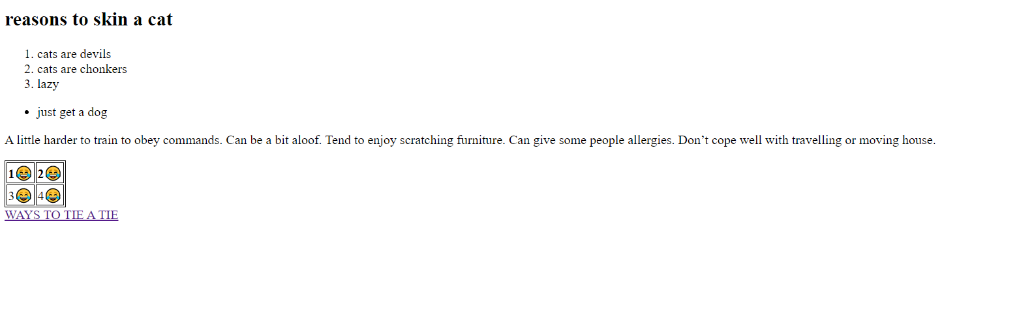

**3.html::**

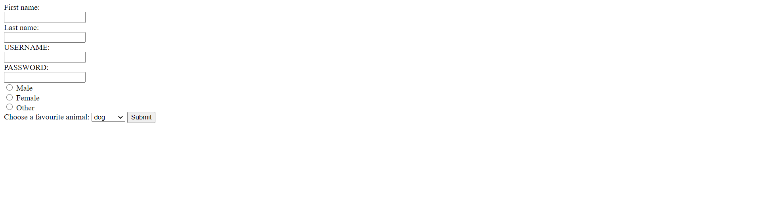

**B.3. Observations and Learning**

The different tags of html can be studied and referenced from the mozilla open source docs they are a great resource.

Links to different html pages in the same filesystem can be done easily whereas web links can also be used for external webpages

**B.4. Conclusion**

1. Understood the basic Technique in building a static web application using HTML

2. Implemented basic tags of HTML

3. Understood usage of basic editor like Sublime Text 2 or 3- personally I use vs code.